YEAR 12 PHYSICS
ROLLING FRICTION INVESTIGATION

Final Report Due: _____ / _____ / _____

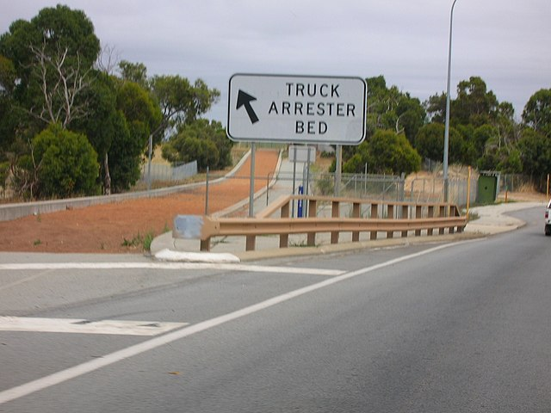
‘Warm up’ question – truck arrester beds.

The photograph on the right shows the ‘emergency truck arrester bed’ near the bottom Great Eastern Highway near Midland. It’s located near the bottom of the very long Greenmount Hill.

Large trucks carrying heavy loads are in danger of experiencing brake failure when going down a steep hill. The driver of such a runaway truck has the chance to steer their truck onto the arrester bed to make an emergency stop. The arrester bed has a deep layer of gravel, which is soft enough to provide the necessary retarding force to stop the truck within the length of the bed (about 200 m).

Problem

An 11-tonne truck on Greenmount Hill experiences brake failure and begins to freewheel down the hill. The motion can be considered frictionless as it descends the hill. The driver steers the truck onto the arrester bed, which thankfully brings it to a stop in 120 m. If the truck was at an altitude 80 m above the arrester bed when its brakes failed, calculate the average force exerted by the gravel as it brings the truck to a stop.

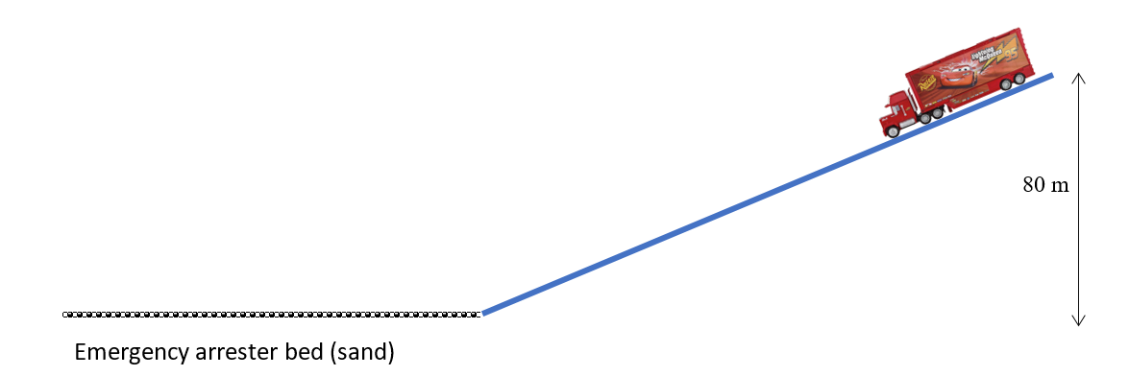

You are now ready for the investigation!

AIM
To study the effect of weight on rolling friction on a carpet.

NOTES ON METHOD
We will use an incline to accelerate the trolley to (hopefully!) the same known velocity each trial. The trolley will then hit the horizontal carpet (the floor) and the friction between the carpet and the wheels will decelerate the trolley to rest. In this way (and by making a few obvious assumptions) we can calculate the average frictional force on the trolley when on the carpet.

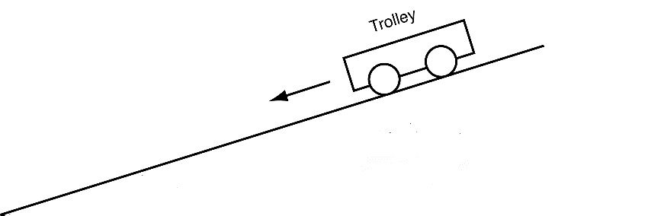
carpet
ramp

A

ramp

B
C

PART 1 – Testing the ramp
Ideally, the ramp we use will have negligible rolling friction and this should be the case with a good trolley and a ramp with a hard surface. However, it is possible to test this assumption, so we should make the attempt. Measuring the length of the trolley’s path on the ramp, and the time it takes to reach the bottom and performing a simple calculation allows us to test whether the acceleration is close to the theoretical frictionless acceleration we expect down an incline at a given angle, θ. However, much will depend on how accurate your measured time is.

Set up this ‘pre-experiment’ and analyse the results. If you can definitively show that the ramp is nearly frictionless, then assume it is. Otherwise, you will need to use your results from Part 1 to calculate the expected final velocity at this angle and use this number for Part 2.

PART 2 – The investigation
You will be varying the mass in the trolley, but if time permits, you should perform the experiment for at least two different ramp angles – for comparison. Although we are not testing different starting velocities (i.e. ramp angles), trying it for at least 2 angles will at least give you an idea whether speed is a factor that affects frictional force

NOTES ON EQUIPMENT
Below is a list of some obvious equipment you will need. This is enough to perform the basic measurement of the average frictional force, but more equipment will be needed if your experiment is to be as thorough or accurate as possible. This may be equipment you can supply yourself (materials/devices/equipment you carry with you at school every day), equipment stored in the room, or it may be something you need to order in advance of your lab next lesson (see the teacher during this period or afterward).

• dynamics trolley with mass
• ramp
• tape measure
• brass masses
• stopwatch

NOTES ON MEASUREMENTS AND CALCULATIONS
You should now join with the other members of your group and ensure that you
• agree on how you will set up the experiment
• identify and plan for any ways you can improve the experiment
• identify any other equipment you will need and are ready to order it if need be
• know which measurements you will be taking and how
• can (each) perform all the calculations necessary to determine the average frictional force from the carpet.
• agree on the assumptions you are making in these calculations

NOTES ON YOUR REPORT
A full individual report must be submitted for this experiment.

Standard | A | B | C | D | E |  | Important Notes to Students & Teachers on Achieving the ‘A’ Standard
Hypothesis | Formulates/states a relevant, testable hypothesis that describes a quantifiable relationship between the dependent and independent variables.  (4) | Formulates/states a relevant, testable hypothesis that describes a relationship between the dependent and independent variables.  (3) | Formulates/states a testable hypothesis that includes the dependent and independent variables.  (2) | Identifies one or more relevant variables.  (1) | Does not meet the requirements of a D grade.  (0) |  | A hypothesis is a testable (falsifiable), scientific statement upon which your experiment is based, linking a change in the independent variable to a response in the dependent variable. Phrase as an "if/then/because" statement.  i.e. if I [state measurable change] to [independent variable], then [state second measurable change] should be observed for [dependent variable], because [statement about theory behind experiment].
Planning & Conducting Investigation  (Introduction, Equipment & Method) | Plans and conducts investigations, identifying appropriate variables and explaining how they are controlled.  (4) | Plans and conducts investigations, identifying and controlling appropriate variables.  (3) | Plans and conducts investigations identifying and controlling some variables.  (2) | Plans investigations without controlling variables.  (1) | See above.  (0) |  | Be sure to include the following in your report:  - A brief introductory paragraph or so detailing the theory behind the experiment, such as a short paragraph on the theory of rolling friction, would be appropriate. Be sure to discuss relevant variables (see rubric).  - Any pre-lab questions you were asked to complete (if applicable).
 | Describes experimental method in detail, with labelled diagrams of setup.  (4) | Describes the experimental method. Includes diagram of setup.  (3) | Briefly outlines the experimental method.  (2) | Describes an experimental method that lacks detail.  (1) | See above.  (0) |  | Method: Detail the steps your group took in the experiment. Be explicit.  Equipment: List the equipment you used. Draw the experimental setup and label your diagram(s). Figure should be at least one-third of a page in size.
Organisation of Data  (Results) | Accurately collects valid and reliable data. Consistently organises and processes data accurately, including uncertainty of measurement.  (8-7) | Accurately collects appropriate data. Often organises and processes data accurately.  (6-5) | Collects data. Organises and processes data with minor errors or omissions.  (4-3) | Collects insufficient or inappropriate data. Organises and processes data with significant errors or omissions.  (2-1) | See above.  (0) |  | Be sure to include the following in your report:  - Provide relevant measurements, with uncertainties, used to test the assumption of negligible rolling friction of the ramp (Part 1).  - Provide relevant measurements, with uncertainties, used to determine the speed at the bottom of the ramp.  - Provide relevant measurements, with uncertainties, used to determine the average friction force of the carpet (Part 2).  - Provide relevant measurements, with uncertainties, used to determine how average friction force of the carpet changes with the mass if the trolley (Part 2).
 | Presents data logically in a range of forms, including graphs, tables, and diagrams.  (4) |  | Presents data in basic graphs, tables, and diagrams.  (2) | Presents data that is unclear, insufficient and lacks appropriate processing.  (1) | See above.  (0) |  | Be sure to include the following in your report:  - Uncertainties can be represented graphically using error-bars (must show how they were calculated – see ‘Analysis of Data’).
Analysis of Data  (Discussion) | Comprehensively explains trends using quantitative data, where appropriate, as evidence to draw conclusions that relate to the hypothesis.  (8-7) | Explains trends using some quantitative data, where appropriate, and uses evidence to draw conclusions that relate to the hypothesis.  (6-5) | Describes trends in data and draws simple conclusions that may not link to the hypothesis.  (4-3) | Identifies trends in data incorrectly or overlooks trends and draws simple conclusions that are not always supported by the data or are not related to the hypothesis.  (2-1) | See above.  (0) |  | Be sure to include the following in your report:  - Provide relevant calculations used to test the assumption of negligible rolling friction of the ramp (Part 1).  - Provide relevant calculations used to determine the speed at the bottom of the ramp.  - Provide relevant calculations used to determine the average friction force of the carpet (Part 2).  - Provide relevant calculations used to determine how average friction force of the carpet changes with the mass if the trolley (Part 2).  - Provide relevant calculations demonstrating the propagation of uncertainties as appropriate. | - State assumptions made (if any) at each stage of calculation.  *If you need to perform the same calculation repeatedly for different data points, you may provide one fully-worked sample calculation and provide the results of the remaining calculations of the same type in an appropriate format (i.e., table, graph). You may repeat this for each separate set of calculations that you need to perform.  - Explain your results and what you can infer from them (i.e. state whether your results support your hypothesis and explain why or why not, with reference to your results).
Evaluation of Experiment  (Discussion) | Evaluates the experimental method and provides specific and relevant suggestions to improve the reliability of the data collected.  (8-7) | Evaluates the experimental method and provides relevant suggestions to improve the reliability of the data collected.  (6-5) | Provides general suggestions to improve the reliability of the data collected.  (4-3) | Provides suggestions to improve the reliability of the data collected that may not be feasible.  (2-1) | See above.  (0) |  | Be sure to include the following in your report:  - Identify any potential sources for systematic and random error.  - Comment on the validity (a fair test of the hypothesis) and reliability (consistency of results upon repeat experimentation - reproducibility) of the experiment. Usually links back to control variables.  - Suggest improvements to the experiment to improve validity and reliability. Usually this is discussed in terms of improving accuracy and precision, or reducing uncertainty size. Sample calculations should be provided to show how uncertainty size would be reduced.
Communication | Communicates detailed information and concepts logically and coherently.  (4) | Communicates information and concepts logically.  (3) | Communicates information and concepts simply.  (2) | Communicates information ineffectively.  (1) | See above.  (0) |  | Normally, you would also ensure you include any post-lab questions you were asked to complete after the discussion (not applicable for this investigation).
 | Consistently uses appropriate terminology and conventions.  (4) | Often uses appropriate terminology and conventions.  (3) | Sometimes uses appropriate terminology and conventions.  (2) | Rarely uses appropriate terminology and conventions.  (1) | See above.  (0) |  | Relevant Conventions:  - References: Make note of any relevant references used in this investigation. Attempt to use a formal referencing convention (Chicago/Harvard/APA).  - Diagrams should be numbered as ‘Figure 1’, ‘Figure 2’, etc., with description immediately below the figure.  - Tables should be numbered as ‘Table 1’, Table 2’, etc., with description immediately above the table.

